## Create VM

1. First select the project where you want to create VM
2. At hamburger menu go to Compute engine>VM Instances

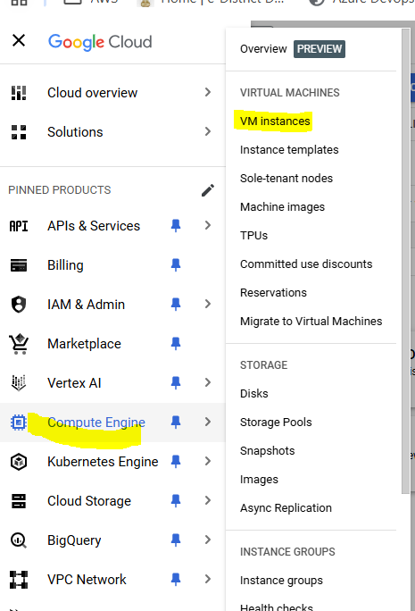

1. For first time creation, we need to enable Compute engine API, so click Enable

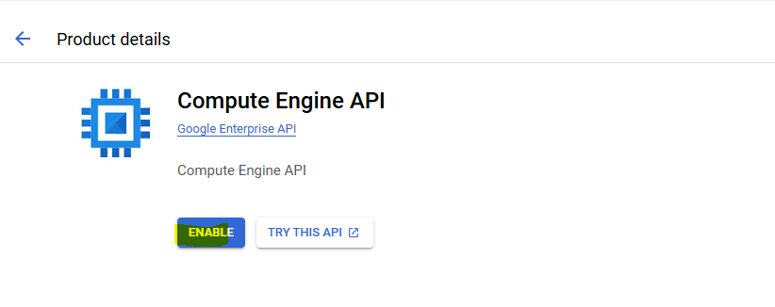

1. Here we can see list of our existing instances, to create new click “Create Instance” button

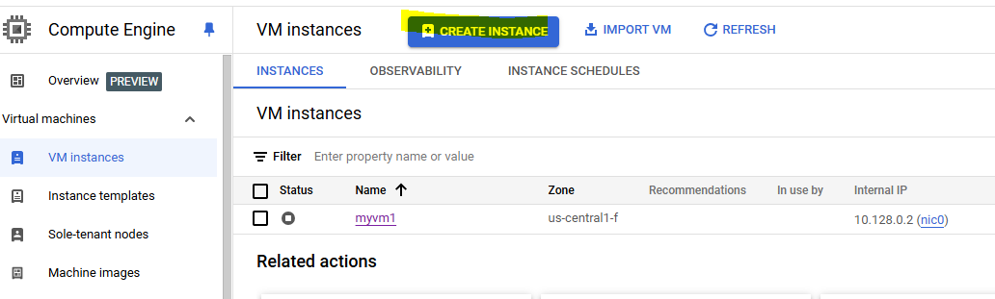

1. Give instance a name, select region and zone
2. Select shape

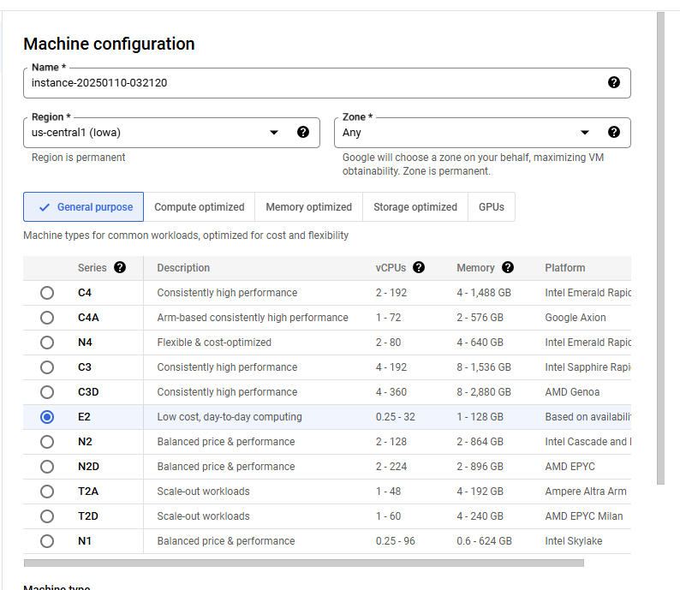

1. Keep rest details default and click create

## Connect VM

1. Make sure Instance is at running state

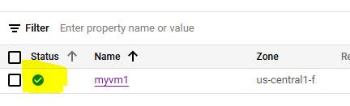

1. Go to ssh option and click open in browser

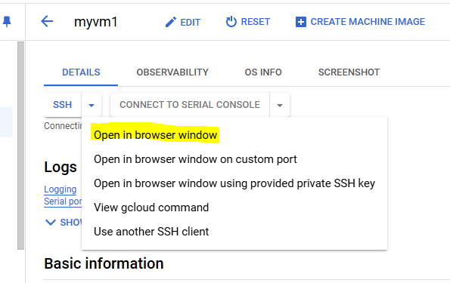

1. A new window will open, click “Authorize” button if asked

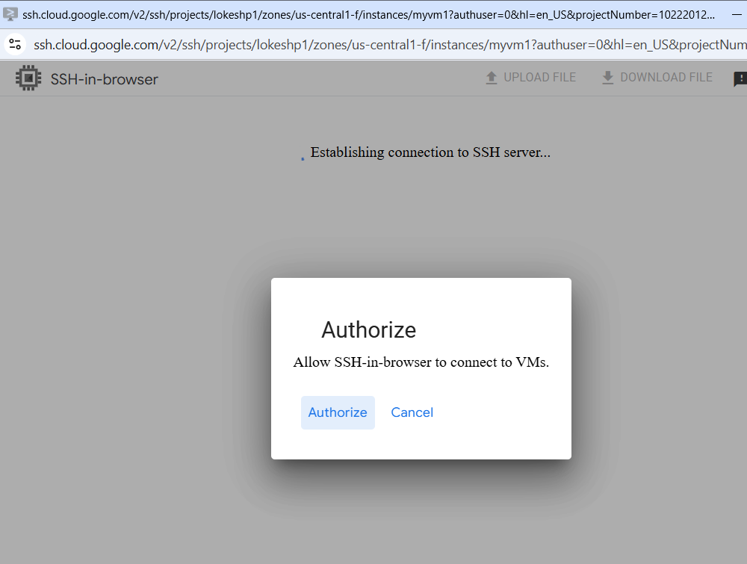

1. Now you have logged in to the vm

